ACC, HIMSS and RSNA
Integrating the Healthcare Enterprise

IHE Patient Care Coordination Technical Framework

Supplement 2005-2006

<Profile Name
(Profile Acronym)>

Draft for Public Comment Version

Comments due July 15, 2006

Foreword
Integrating the Healthcare Enterprise (IHE) is an initiative designed to stimulate the integration of the information systems that support modern healthcare institutions. Its fundamental objective is to ensure that in the care of patients all required information for medical decisions is both correct and available to healthcare professionals. The IHE initiative is both a process and a forum for encouraging integration efforts. It defines a technical framework for the implementation of established messaging standards to achieve specific clinical goals. It includes a rigorous testing process for the implementation of this framework. And it organizes educational sessions and exhibits at major meetings of medical professionals to demonstrate the benefits of this framework and encourage its adoption by industry and users.
The approach employed in the IHE initiative is not to define new integration standards, but rather to support the use of existing standards, HL7, DICOM, IETF, and others, as appropriate in their respective domains in an integrated manner, defining configuration choices when necessary. IHE maintain formal relationships with several standards bodies including HL7, DICOM and refers recommendations to them when clarifications or extensions to existing standards are necessary.
This initiative has numerous sponsors and supporting organizations in different medical specialty domains and geographical regions. In North America the primary sponsors are the American College of Cardiology (ACC), the Healthcare Information and Management Systems Society (HIMSS) and the Radiological Society of North America (RSNA). IHE Canada has also been formed. IHE Europe (IHE-EUR) is supported by a large coalition of organizations including the European Association of Radiology (EAR) and European Congress of Radiologists (ECR), the Coordination Committee of the Radiological and Electromedical Industries (COCIR), Deutsche Röntgengesellschaft (DRG), the EuroPACS Association, Groupement pour la Modernisation du Système d'Information Hospitalier (GMSIH), Société Francaise de Radiologie (SFR), Società Italiana di Radiologia Medica (SIRM), the European Institute for health Records (EuroRec), and the European Society of Cardiology (ESC). In Japan IHE-J is sponsored by the Ministry of Economy, Trade, and Industry (METI); the Ministry of Health, Labor, and Welfare; and MEDIS-DC; cooperating organizations include the Japan Industries Association of Radiological Systems (JIRA), the Japan Association of Healthcare Information Systems Industry (JAHIS), Japan Radiological Society (JRS), Japan Society of Radiological Technology (JSRT), and the Japan Association of Medical Informatics (JAMI). Other organizations representing healthcare professionals are invited to join in the expansion of the IHE process across disciplinary and geographic boundaries.
The IHE Technical Frameworks for the various domains (IT Infrastructure, Cardiology, Laboratory, Radiology, etc.) defines specific implementations of established standards to achieve integration goals that promote appropriate sharing of medical information to support optimal patient care. It is expanded annually, after a period of public review, and maintained regularly through the identification and correction of errata. The current version for these Technical Frameworks may be found at www.ihe.net/Technical_Framework.
The IHE Technical Framework identifies a subset of the functional components of the healthcare enterprise, called IHE Actors, and specifies their interactions in terms of a set of coordinated, standards-based transactions. It describes this body of transactions in progressively greater depth. The volume I provides a high-level view of IHE functionality, showing the transactions organized into functional units called Integration Profiles that highlight their capacity to address specific clinical needs. The subsequent volumes provide detailed technical descriptions of each IHE transaction.
This supplement to the IHE Patient Care Coordination Technical Framework V1.0 is submitted for Public Comment between June 15, 2006 and July 15, 2006, per the schedule announced in February 2006

Comments shall be submitted before July 15, 2006 to:
http://forums.rsna.org under the “IHE” forum
Select the “IHE Patient Care Coordination Supplements for Public Review” sub-forum.

The IHE Patient Care Coordination Technical Committee will address these comments and publish the Trial Implementation version in August of 2006.

Date: <June 14, 2004>
Author: <Charles Parisot>
These ”boxed” instructions for the author to indicate to the Volume Editor how to integrate the relevant section(s) into the overall Technical Framework

Introduction
<provide a brief overview of the volumes/ sections of the Technical Framework that get changed/ added by this profile>

Open Issues and Questions
< List of open issues/ questions that need to be addressed prior to publishing of the Technical Framework>

Closed Issues
< List of closed issues/ questions with their resolutions that have been addressed prior to publishing of the Technical Framework>

Profile Abstract
<200 words or less describing this profile – goes in Executive Summary document>

GLOSSARY
<any glossary additions associated with the profile draft go here>

Volume I – Integration Profiles
<This section describes the changes required in Volume I of the Technical Framework that result form including this Integration Profile.>

Changes to Sections 1 – 1.X
<Include a subsection for each section/ subsection changed>

1.7 History of Annual Changes
<Brief description of what to add to Volume I, section 1.7 which gives a brief overview of “what’s new” in the given year of the Technical Framework.>
Add the following bullet to the end of the bullet list in section 1.7
- Added the XYZ Profile which does blah, blah, blah…..

Y <XYZ> Integration Profile Dependencies

X <XYZ> Integration Profile
<Description/ overview of Integration Profile>

X.1 Actors/ Transactions
<Actor/ Transaction diagram and Actor/ Transaction table. >
Figure X.1-1 shows the actors directly involved in the <XYZ> Integration Profile and the relevant transactions between them. Other actors that may be indirectly involved due to their participation in <other related profiles>, etc. are not necessarily shown.

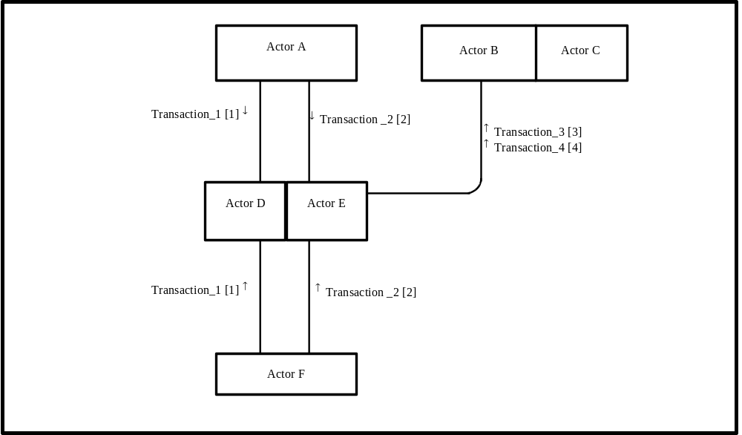
Figure X.1-1. <XYZ Profile> Actor Diagram
Table X.1-1 lists the transactions for each actor directly involved in the <XYZ> Profile. In order to claim support of this Integration Profile, an implementation must perform the required transactions (labeled “R”). Transactions labeled “O” are optional. A complete list of options defined by this Integration Profile and that implementations may choose to support is listed in Volume I, Section X.2.

Table X.1-1. <XYZ> Integration Profile - Actors and Transactions
Actors | Transactions | Optionality | Section in Vol. 2
Actor A | Transaction_1 | R | Z.1
Actor A | Transaction_2 | R | Z.2
Actor F | Transaction_1 | R | Z.1
Actor F | Transaction_2 | R | Z.2
Actor D/ Actor E | Transaction_1 | R | Z.1
Actor D/ Actor E | Transaction_2 | R | Z.2
Actor D/ Actor E | Transaction_3 | R | Z.3
Actor D/ Actor E | Transaction_4 | R | Z.4
Actor B (Actor C) | Transaction_3 | R | Z.3
Actor B (Actor C) | Transaction_4 | R | Z.4
Note: This is a note

X.2 <XYZ> Bindings
Content bindings describe how the payload used in the transactions of an IHE profile is related to and/or constrains the data elements sent or received in those transactions. This section is where any specific dependencies between the content and transaction are defined. The Patient Care Coordination Technical Framework defines one content binding, to the ITI Cross Enterprise Sharing profile.
Error: Reference source not found describes the content that may be used with each transaction.
Transaction | Content | Optionality | Binding | Definition
Provide and Register Document Set  Query Registry  Retrieve Document | Discharge Summary | O (Note 1) | PCC TF-1: 3.4.1.1
Provide and Register Document Set  Query Registry  Retrieve Document | Referral | O (Note 1) | PCC TF-1: 3.4.1.2
Table 4.4-1 Transactions and Content
Note 1: At least one type of content from this table must be used with the specified transaction (from the sender or receiver side) in order for the transaction to meet the requirements of the XDS-MS profile.

X.3 <XYZ> Content Profiles
<Content profiles describe the content of a payload found in an IHE transaction. Content profiles are transaction neutral. They do not have dependencies upon the transaction that they appear in. These dependencies are reflected in the Bindings listed above.>

X.3.1.1 Discharge Summary
All discharge summaries shall be structured and coded as required by the Discharge Summary Content Profile specified in section 5.7. The inclusion of the specific coded attributes explicitly defined as optional, may be supported by specific implementations of Document Sources using an IHE identified coded terminology (See PCC TF-3: Appendix A) of their choice. The requirements and manner in which implementations support such capabilities is beyond the scope of this Integration Profile.

X.4 <XYZ> Integration Profile Options
<Table describing the options available for this integration profile>
Options that may be selected for this Integration Profile are listed in the table X.2-1 along with the Actors to which they apply. Dependencies between options when applicable are specified in notes.
Table X.2-1 Evidence Documents - Actors and Options
Actor | Options | Vol & Section
Actor A | No options defined | - -
Actor F | No options defined | - -
Actor D/ Actor E | No options defined | - -
Actor D/ Actor E | No options defined | - -
Actor B (Actor C) | No options defined | - -
Actor B (Actor C) | No options defined | - -

X.3 <XYZ Integration Profile> Process Flow
<Description of the process flow(s) and sequence diagram(s) covered by this profile in order to satisfy the use cases. This often will include a brief description of the use cases as well. If there are detailed behavioral rules that apply to a specific process flow or multiple process flows or descriptions then an appendix may be added as needed>

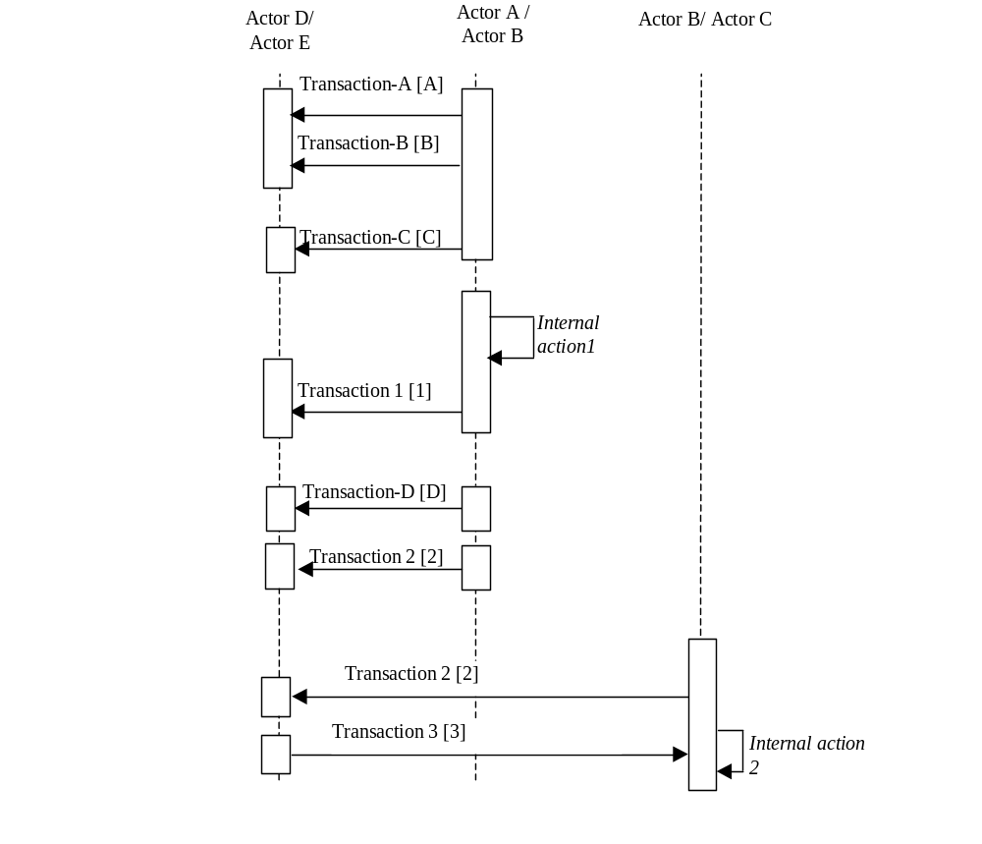
Figure X.2-1. Basic Process Flow in XYZ Profile
<Appendix A> Actor Summary Definitions
<add any actor definitions for new actors defined specifically for this profile>
<Appendix B> Transaction Summary Definitions
<add any transaction definitions for new transactions defined specifically for this profile>

<Describe changes to volume II below>

Introduction
<provide a brief overview of the volumes/ sections of the Technical Framework that get changed/ added by this profile>

Open Issues and Questions
< List of open issues/ questions that need to be addressed prior to publishing of the Technical Framework>

Closed Issues
< List of closed issues/ questions with their resolutions that have been addressed prior to publishing of the Technical Framework>

Profile Abstract
<200 words or less describing this profile – goes in Executive Summary document>

GLOSSARY
<any glossary additions associated with the profile draft go here>
<Describe changes to volume II below>

Content Profile

IHE PCC Template Identifiers
Add the following row to the list of IHE PCC Template Identifiers

extension | Description
XDS-HP-2006 | The template identifier used to indicate that a CDA document conforms to the Preoperative History and Physical Content specification.

Add the following section to the IHE Content Profiles Section of Volume II of the Patient Care Coordination Technical Framework.

Preoperative History and Physical Content

Dependencies
A preoperative history and physical is a type of medical document, and incorporates the constraints defined for medical summaries found in section 5.3 Medical Documents above.

Conformance
Need a template identifier for this document type.

Constraints
A preoperative history and physical is a type of medical summary, however, it is identified using a different document type than is defined by the HL7 Care Record Summary. Therefore, this content specification adopts all Level 1 and Level 2 constraints and extensions defined by the Care HL7 Care Record Summary with the exception of those specific to document type.
The LOINC Document Type code shall be: TBD
This section defines additional constraints for Medical Summary Content used in a Preoperative History and Physical. These tables present the Categories, as defined in Section 3 of CRS. Please refer to Section 3.3.1 for the methodology used to map Use Cases to CRS Categories.
- CRS Section Constraints on CDA R2
  - CRS Section Category
  - Required, Optional, or Conditional Use as defined by CRS.
  - LOINC Code for the Category, as defined by CRS or as an additional LOINC code
  - Component Name in LOINC, as defined by CRS
- IHE Constraints
  - IHE Use Case Content – as defined by the requirements of the IHE Use Case; where this column is blank there is still an option to provide information in this Category but no requirement from the IHE Use Case.
  - Profile Use communicates the Content status within the IHE Profile, i.e. Required (R); Required when available (R2) or Optional (O) as defined by the requirements of the IHE Use Case.
In no case are these IHE requirements less strict than those defined by CRS.
Table 5.5-2: IHE Acute Care Discharge Constraints on CRS
CRS Section Constraints on CDA R2 |  |  |  | IHE Constraints on CRS
Category | Use | LOINC Code | Full LOINCName | IHE Use Case Content | Profile  Use
Conditions | R | 11450-4 | PROBLEM LIST-FIND-PT-^PATIENT-NOM-REPORTED | 2.9 Active Problems | R
Conditions | R | 11348-0 | HISTORY OF PAST ILLNESS-FIND-PT-^PATIENT-NAR-REPORTED | 2.10 Resolved Problems | R
Conditions | R | 11535-2 | HOSPITAL DISCHARGE DX-IMP-PT-^PATIENT-NAR | 2.8 Discharge Diagnosis | R
Conditions | R | X-HADX | HOSPITAL ADMISSION DX | 2.5 Admitting Diagnosis | R
Medications | R | 10160-0 | HISTORY OF MEDICATION USE-FIND-PT-^PATIENT-NAR-REPORTED | 2.11 Selected Meds Administered | R2
Medications | R | 10183-2 | HOSPITAL DISCHARGE MEDICATIONS-FIND-PT-^PATIENT-NAR | 2.12 Discharge Meds | R
Medications | R | X-MOA | MEDICATIONS ON ADMISSION |  | R2
Allergies and Adverse Reactions | R | 10155-0 | HISTORY OF ALLERGIES-FIND-PT-^PATIENT-NAR-REPORTED | 2.13 Allergies | R
Hospital Course | C | 8648-8 | HOSPITAL COURSE-FIND-PT-^PATIENT-NAR | 2.7 Hospital Course | R
Advance Directives | O | X-ADVDIR | ADVANCE DIRECTIVES |  | O
History of Present Illness | O | 10164-2 | HISTORY OF PRESENT ILLNESS-FIND-PT-^PATIENT-NAR-REPORTED | 2.6 History of Present Illness | R2
Functional Status | O | 10158-4 | HISTORY OF FUNCTIONAL STATUS-FIND-PT-^PATIENT-NAR-REPORTED |  | O
Functional Status | O | X-FS | Needs new code for Functional Status | 2.17 Functional Status | O
Review of Systems | O | 10187-3 | REVIEW OF SYSTEMS-FIND-PT-^PATIENT-NAR-REPORTED | 2.15 Review of Systems | O
Physical Exam |  | 10184-0 | HOSPITAL DISCHARGE PHYSICAL-FIND-PT-^PATIENT-NAR
Physical Exam |  | 8716-3 | VITAL SIGNS, PHYSICAL FINDINGS-FIND-PT-VITAL SIGNS-NAR-OBSERVED | 2.16 Vital Signs | R2
Studies and Reports | O | 11493-4 | HOSPITAL DISCHARGE STUDIES SUMMARY-FIND-PT-^PATIENT-NAR | 2.18 Discharge Procedures 2.19 Tests, Reports | R
Care Plan | O | 18776-5 | TREATMENT PLAN-FIND-PT-TREATMENT PLAN –NAR | 2.20 Plan of Care | R
Care Plan |  | X-DD | DISCHARGE DIET | 2.14 Discharge Diet | O

Content for the Preoperative History and Physical
This use case is described fully in PCC TF-1:3.8.2. Briefly, it involves an episodic transfer of care in the form of a patient discharge from a hospital to home.
Using the use cases described in PCC-TF-1-3.8.2, the contents of documents used in collaborative transfers of care were discussed with physicians and nurses in detail to identify major sections. The sections identified by physicians as important are listed in the table below under the column “Use Case Documentation Section”
Using this information, the following constraints have been applied to the relevant sections in the Care Record Summary category cross-reference table using the same definitions described for use case 1.
Number | Use Case Document Section | Constraint on CRS | CRS Catgeory
2.1 | Date of Admission | R | Header.[effectiveTime]
2.2 | Date of Discharge | R | Header.[effectiveTime]
2.3 | Participating Providers and Roles | R | Header.[Participants]
2.4 | Discharge Disposition (including who, how, where) | R | Care Plan
2.5 | Admitting Diagnosis | R | Conditions.[Hospital Admission Dx]
2.6 | History of Present Illness | R2 | History of Present Illness
2.7 | Hospital Course | R | Hospital Course
2.8 | Discharge Diagnosis (including active and resolved problems) | R | Conditions.[Hospital Discharge Dx]
2.11 | Selected Medicine Administered during Hospitalization | R2 | Medications.[History of Medication Use]
2.12 | Discharge Medications | R | Medications.[Hospital Discharge Medications]
2.13 | Allergies and adverse reactions | R | Allergies and Adverse Reactions
2.14 | Discharge Diet | O | Optionally found in Care Plan
2.15 | Review of Systems | O | Review of Systems
2.16 | Vital Signs (most recent, high/low/average) | R2 | Physical Exam.[Vital Signs, Physical Findings]
2.17 | Functional Status | O | Functional Status
2.18 | Relevant Procedures and Reports (including links) | R | Studies and Reports
2.19 | Relevant Diagnostic Tests and Reports (including links) | R | Studies and Reports
2.20 | Plan of Care | R | Care Plan
2.21 | Administrative Identifiers | R | Header
2.22 | Pertinent Insurance Information | O | Header

